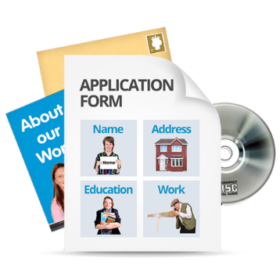
Our Future Leaders
Application Form
For course beginning 31st May 2022

If you are interested in applying please fill in the form

If you need extra space to write your answer you can use a blank sheet of paper.

We will look at everybody’s answers. Then we will decide who will get a place on the next leadership course.

Not everyone will be chosen because there is not space on the course for everyone.

Application Form

What is your name:
What is your address and postcode?

What is your telephone number?

What is your email address?

You will need to be able to use email for the course. Your links to the Zoom sessions will be sent by email.

Tell us about you. What are you interested in? what things do you do? What kind of support do you get to live your life? Please write your answer in the box below:

Why are you interested in being a future leader?
Please write your answer in the box below:

Do you need anything to help you to read and understand written information?

Everyone in the course needs to have a sponsor?
Please tell us who will be your sponsor and how we can contact them? Sponsors should read the information about sponsors so they know what is involved.

Please email your application to us by
29th April 2022
Send your application to both of these email addresses.
Catriona.r@scld.co.uk
and
elaine@inspiringscotland.org.uk

Thank you for taking the time to send us your application.

