What this Easy Read is about

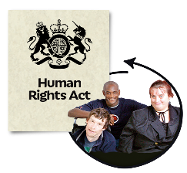 | This is an easy read for organisations that are working to make sure people get their human rights.
 | It is some information about some money that is available to help to pay for work that is about human rights.
 | You can now apply to a fund to pay for the work you want to do.
The fund is called The Equality and Human Rights Fund.

From now on we will call it the Fund.

Who can apply?

The Fund is to pay for work that helps people get their human rights.

One organisation can apply on its own.

A group of organisations can apply if they want to work together.

Only organisations can get money from the Fund, not individuals.

Organisations need to be charities or
community run companies.

Money making businesses cannot apply.

When the money will be available.

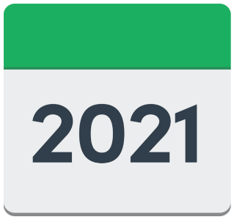 | The Fund will start in October 2021.
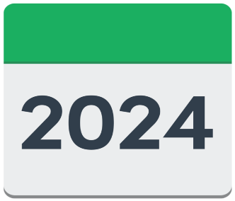 | It can go on till September 2024.
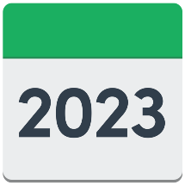 | You have to apply now for work that will start in 2022 or 2023.

How much money is available?
The Fund has £7 million each year.
There is no limit to the amount you can ask for.
But you must show that your work will help people to get their human rights.

What kind of things will get money?
 | The funding is only for certain things.
 | The next 2 pages tell you the kind of things that can get money from the Fund.
 | Giving information or training about human rights.
 | Giving legal advice and representing people in court.
 | Helping people get access to public services.
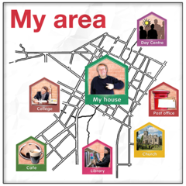 | Helping people become more active members of their communities.
 | Helping people to get together and claim their human rights as a group.
 | Doing more research into human rights.

How do I apply?
First, say that you are interested by clicking on this link https://survey.alchemer.com/s3/6200402/Equality-Human-Rights-Fund-Expression-of-Interest-form

You will then be sent an application form.
You will need to send in other documents.

They will tell you what these documents are.

The deadline for applying is 14th May 2021

What if I need help to apply?
You can get more information about applying by contacting Louise from Inspiring Scotland.
Her phone number is 07398 088 049
Her email address is EHRenquiries@inspiringscotland.org.uk
She will give you more information about the Fund
She will help you apply for the Fund if you cannot apply online

